**Uploading documents and assigning permissions**

**Step 1:** Click the highlighted tab and a drop-down menu will appear. Choose the options available in the drop-down menu to create or upload a new document.

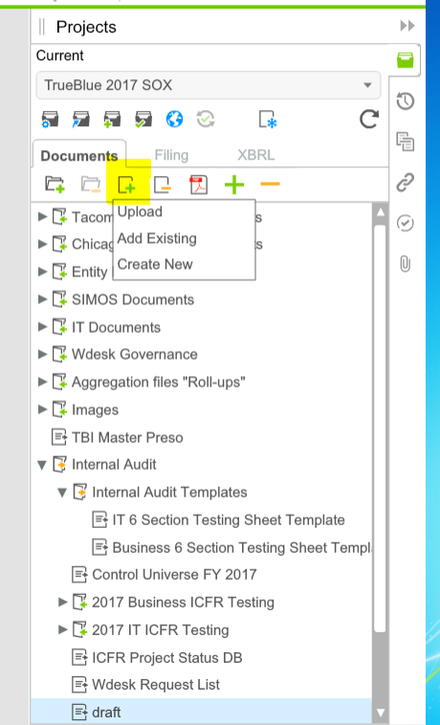

Step 2: Right click on the file that requires permission access changes, for example, permission Control Manual. A menu will appear and click properties.

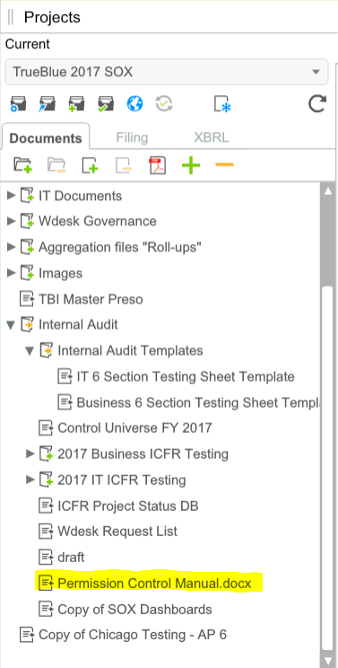

Step 3: Click “Permissions” and then “Edit permissions”.

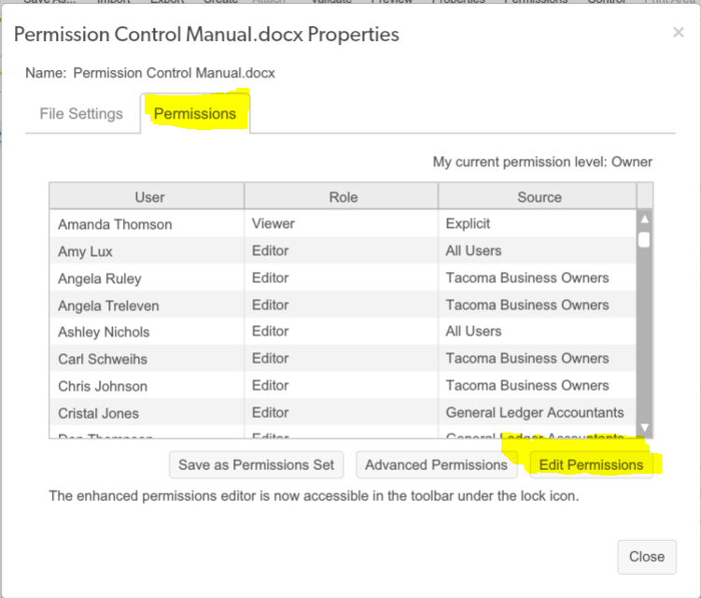

Step 4: There are options to remove, add and clear permissions. When uploading a document, please remove all users with the exception of “**Internal Audit Testers**.” This will restrict access to our Internal Audit documents to all users except for our Internal Audit team. After making required changes on the accessibility of the file edited, click “Apply changes”. To grant Deloitte access to our working papers, select the individual working papers and “Add permission.”

